|  |  |  |
| --- | --- | --- |
|  |  | Invisible Touch screen |

# Abstract

With the modernization of world the technology arbitrarily demands touch screen. The resources that provide touch screen is also sufficient and can include various improvements for the future. Although the resources are available , it is not made cost friendly to the customers. The larger touch screen pixel area requires more temporary memory to parse as well as the cost factor is stuck to it. This might be a possible explanation why we don’t get every gadget- despite its size- in touch screen. Our initiative is to reduce this complexity and solve the other possible drawbacks faced by the current touch screen

We have built an alternative for the 2d touch screen and can also be extended for the 3d space in later future. It utilizes the high frequency light as in laser that forms a pattern of structure that depict the screen surface. If this boundary are cut , it is reflected as a human touch. The simplification to this brought out using a no memory device as in Arduino boards. It acts as a interface for the transfer of touch signals to the computer which can process from it.

# Introduction

Touch screen has become an essential component in any piece of gadget. It has been developed and it has grown in its place has become a vital chair. There is no need to reinvent the wheel but there is always a possibility to make it better. The touch screen today are fragile and are damaged very easily. The breakage of a touch screen is costlier than any ordinary screen. The current technology is an enemy towards water and the screen are water sensitive. This affects the circuitry and not possible to rectify with the old one.

With the advent of VR , the need for a 3d sensitive touch is much need and our product can be extended to support 3d. With the precise calculations and resources we can track exactly the movement as well as implement it back.

The world is a quiet changing realm and needs to be updated to the reality. The possibilities of the current product is endless and it is an effective way to subtly change to this model.

# Implementation

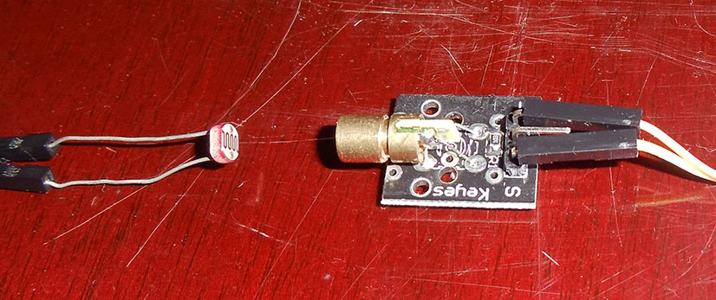

For the purpose of implementation the following components are used. Each of the component plays an very important role. The model consists of a frame that is fixed to the size to the size of the computer screen. Along the sides of the frame it is embedded with trans receivers for indicating the touch signals. The transrecievers used for this purpose is a laser and a photodiode. Based on the signal given by receiver we can determine if its touch or not touch signal.

Transreciever: 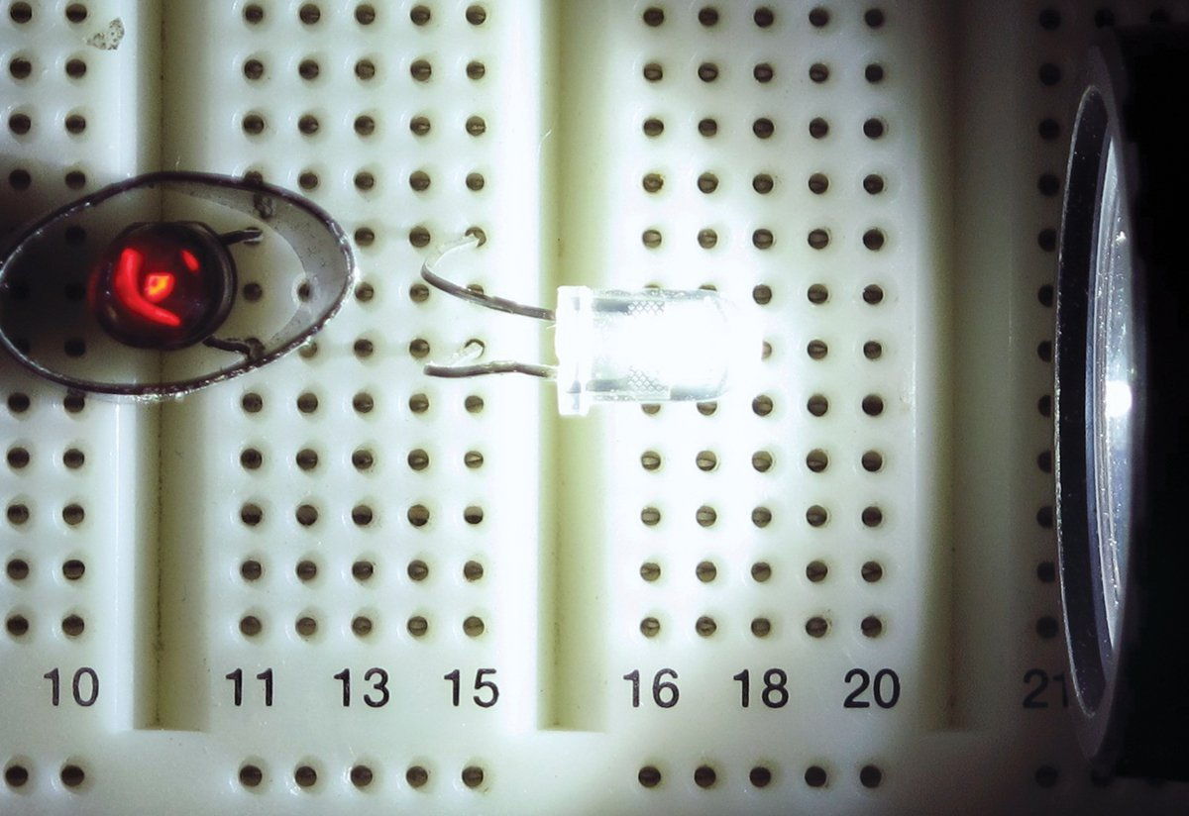

The laser acts as the transmitter. The power is taken from the power signal of the Arduino board. The lasers are fixed at constant positions measured with the scale. The array is set as constant values, if there is a change in the possible values then add it to the existing vector to transform it to a complete answer that can be used for calculation.

The following circuit depecits the laser transmission and recovery using ldr.Light Detector when set with a particular resistance then we get the required output.

The light detecting can be set one frequency which the laser is set to. It can be used to find the specific laser if there are quite confusion with the angle of laser used. It can be separated and used for a fixed resistance or a variable based in the change of the external atmosphere.

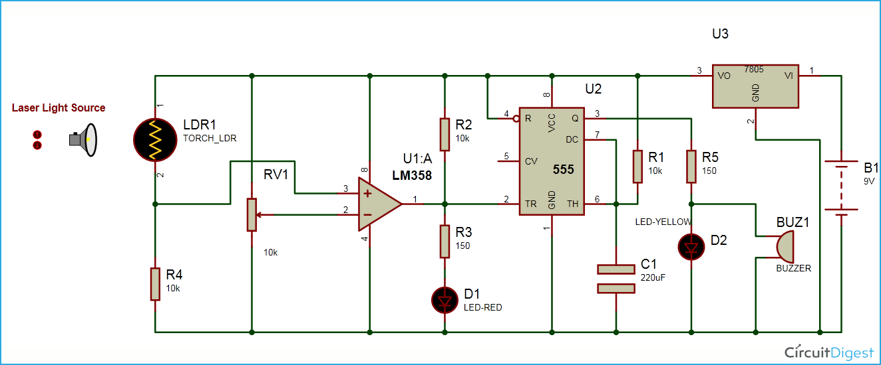

ARDUINO:

The input for the Arduino is arbitrarily assigned to be analog so it can have a deteailed view on what is happening to the signals given. There is a simple c program converting every input of each ldr into a signal that can be sent to the computer interface. The serial monitor converts it and multiplexes in order to suffice many inputs that are present.

# Future work

As specified earlier these are the following works planned:

* Variable length touch screen
* 3d touch screen